Functional Job Description:

Company: | Bluestem Brands, Inc.
Job Title:
Date:
Dept/Facility: | West DC, St. Cloud, MN
Product Section:
Electronic Doc. #

Work Hours | Overtime: | Voluntary and/or mandatory per production requirements. | Breaks: | 10 minutes every two hours, one 30 minute lunch break.
Work Hours | Shift: | Days of week: | Time:
Work Hours | First
Work Hours | Second

Job Rotation | Yes

Job Training or Credentials Required at Hire | Education/ training: | None required; high school diploma or GED preferred.
Job Training or Credentials Required at Hire | Knowledge/ cognitive skills: | Basic math, reading, writing and oral communication skills preferred. Ability to organize work tasks and work independently or as part of a team.

Machines, Tools, Equipment Used

Job Purpose/ Objectives

Safety and Personal Protective Equipment Required  *Available | Hard Hat | Steel Toe Footwear | Safety Glasses | Gloves:
 | Face Shield | Protective Clothing | Safety Glasses/Side Shields | Leather
 | Dust Mask | Safety Vest  Fall Protection Harness  Back Support* | Safety Goggles  Hearing Protection*  Compensatory methods to mitigate heat | Rubberized/cloth*  Chemical

Safety/ Equipment Training/ Certification Required | Daily Meeting and Stretch Breaks (includes:) | Industrial Truck Training | OSHA Training (Rules and Regulations)
Safety/ Equipment Training/ Certification Required | - Safety Topics | EZ-Go | New Hire Safety Orientation
Safety/ Equipment Training/ Certification Required | - Safety Policies | Walkie-Rider | Right to Know
Safety/ Equipment Training/ Certification Required | - Questions & Answers | Pallet Jack | Lockout/Tag Out
Safety/ Equipment Training/ Certification Required | - Review Safety Committee Minutes | Forklift (sit down) | Regulated Materials Training (ORM-D)  Supervisor Safety Updates
Safety/ Equipment Training/ Certification Required | - Review Safety Committee Minutes | Stand-up Reach Truck
Safety/ Equipment Training/ Certification Required | - Review Safety Committee Minutes | Order Picker

Functional Job Elements (Refer to video clip for complete details) | % of Shift

Physical Factors

Manual Material Handling
(lbs) | Floor-Knuckle (0” to 30”) |  |  |  |  |  | Knuckle-Chest (30” to 50’) |  |  |  |  |  | Chest-Overhead  ( > 50”) |  |  |  |  |  | Carry - Two Hands; Front |  |  |  |  |  | Carry - One Hand; Side |  |  |  |  |  | Push |  |  |  |  |  | Pull
100
75
50
25
15
10
5
0
Exp | N | R | O | F | C |  | N | R | O | F | C |  | N | R | O | F | C |  | N | R | O | F | C |  | N | R | O | F | C |  | N | R | O | F | C |  | N | R | O | F | C

Postures/Movements |  |  |  |  |  |  |  |  |  |  |  |  |  |  |  | Head/Neck
Exp | Sit | Stand | Walk | Bal | Stairs | Lad-der | Foot contrl | Twist Waist | Bend Waist | Squat | Kneel | Crawl | Reach below 54” | Reach above 54” |  | Flex Static | Ext Static | Rot Static | Flex Dyn | Ext Dyn | Rot Dyn
C
F
O
R
N

Hand Use |  |  |  |  | Sensory |  |  |  |  |  | Communication |  |  |  |  | Abbreviations: Bal=Balance, Exp=Exposure, Contrl=Control, Flex=Flexion, Ext=Extension, Dyn=Dynamic, Manip=Manipulation
  Key | C - Continuous: 67 to 100% of shift
  Key | F - Frequent: 34 to 66% of shift
  Key | O - Occasional: 6 to 33% of shift
  Key | R - Rarely: up to 5% of shift
  Key | N - Never: 0% of shift
Exp | Simple Grasp | Firm Grasp | Fine Manip | Bal | See | Hear | Touch Feel | Taste | Smell |  | Talk | Read | Write | Hand Signal
C
F
O
R
N

Environmental Factors | Exposure Level |  |  |  |  | Key/Comments
Environmental Factors | N | R | O | F | C | Key/Comments
Outdoor Work |  |  |  |  |  | Comments:  Outdoor Work: Rarely will operate mechanical handling equipment outdoors.  Indoor Work: Primary work area is a large indoor warehouse complex.  Heat: Based on external temperature, occasionally performs job tasks in hot indoor environment; warehouse complex is not air-conditioned. Large fans are used for ventilation.  Moving Objects: Be aware of and avoid moving objects including equipment.  Protected Work Heights: Rarely work at heights – fall protection is in place.
  Key | C - Continuous: 67 to 100% of shift
  Key | F - Frequent: 34 to 66% of shift
  Key | O - Occasional: 6 to 33% of shift
  Key | R - Rarely: up to 5% of shift
  Key | N - Never: 0% of shift
Indoor Work
Heat
Cold
Wet/ Humid
Hearing Protection
Vibration
Fumes/Gases/Orders
Dust
Moving Objects
Electrical
Chemical
Protected Work Heights
Unprotected Work Heights
Flying Debris
Lighting (Inadequate/Excessive)

Position eligible to be considered for temporary modification in conjunction with a Return to Work transitional duty program agreement: Yes
This Functional Job Description was completed through an on-site job analysis by a certified professional ergonomist/licensed physical therapist. It is for the purpose of identifying and quantifying the physical functional requirements of this job. The Functional Job Description should not be construed as a detailed description of all specific job duties and/or tools, equipment and materials that may be necessary or incidental to the performance of this job. Further consideration may be necessary when applying the standards to the injured population in the medical management process.
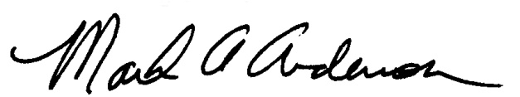 | 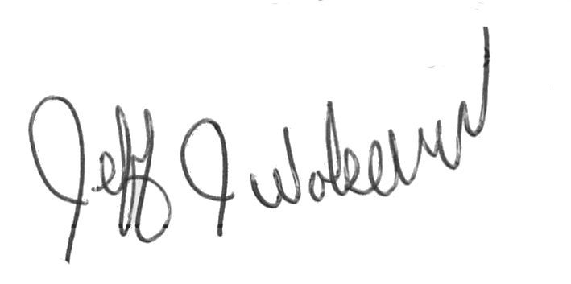  This Functional Job Description has been reviewed by company representatives and is believed to be an accurate representation of most of the job content.
Mark A Anderson, MA, PT CPE  Certified Professional Economist  Licensed Physical Therapist  ErgoSystems Consulting Group, Inc.  19285 Shady Hills Road  Minneapolis, MN 55331  952-401-9296  mark.anderson@ergosystemsconsulting.com  www.ergosystemsconsulting.com | _______________________________________
Jeff Wolseth
Manager - Occupational Safety and Health

 | _______________________________________

